Supporting Information to

Mycobacterial acetyltransferase modifies malate dehydrogenase 1 to regulate host immunity
Running title：Acetyltransferase and malate dehydrogenase 1 in host immunity

Luoxi Zhang^{1,2}#, Yang Yang^{1,2}#, Tianxian Liu³#, Chuyao Lin²#, Aiqiang Zhu^{3,4}#, Junjie Liang¹, Xia Liu¹, Tong Ye³, Danfeng Wang¹, Nana Tian¹, Mei Xiao¹, Jinyu Jia¹, Aijun Qiao^{1,2,3,4}, Yu-Peng Zhou^{1,3}, Yewen Sun¹*, Yanqing Tang¹*, Minjia Tan^{1,2,3,4}*, Jun-Yu Xu^{1,2,3,4,5}*.

¹Zhongshan Institute for Drug Discovery, Shanghai Institute of Materia Medica, Chinese Academy of Sciences, Zhongshan, 528400, China.
²School of Pharmaceutical Sciences, Southern Medical University, Guangzhou 510515, China;
³State Key Laboratory of Drug Research, Shanghai Institute of Materia Medica, Chinese Academy of Sciences, Shanghai, 201203, China
⁴University of Chinese Academy of Sciences, Beijing, 100049, China
⁵Shanghai Key Laboratory of Gene Editing and Cell-based Immunotherapy for Hematological Diseases, Ruijin Hospital Affiliated to Shanghai Jiao Tong University School of Medicine, Shanghai 200025, China
# These authors contributed equally: Luoxi Zhang, Yang Yang, Tianxian Liu, Chuyao Lin, Aiqiang Zhu.
*Correspondence: jyxu@simm.ac.cn (Jun-Yu Xu); mjtan@simm.ac.cn (Minjia Tan); tangyanqing0597@zidd.ac.cn (Yanqing Tang); sunyewen0358@zidd.ac.cn (Yewen Sun)
CONFLICT OF INTEREST STATEMENT: The authors declare no competing financial interest.
AUTHOR CONTRIBUTIONS: Jun-Yu Xu and Minjia Tan conceived and supervised the project; Yanqing Tang conducted animal experiments, contributed and drafting sections of the manuscript with the help of Junjie Liang; Luoxi Zhang and Yang Yang performed majority the experiments and analyzed the data with the help of Chuyao Lin, Aiqiang Zhu and Yewen Sun; Tianxian Liu performed part of experiments and analyzed the data; Luoxi Zhang wrote the manuscript and Xia Liu, Tong Ye, Danfeng Wang, Nana Tian, Mei Xiao, Jinyu Jia, Aijun Qiao, Yu-Peng Zhou. and Yewen Sun revised the manuscript. All authors have read the final manuscript and approved it for publication.
Classification: Biological Sciences; Microbiology
Keywords: Mycobacterium; Secretion acetyltransferase Eis; Mitochondria; Malate dehydrogenase; Immune response
This word file includes:

Figures S1 to S8

Supplementary figures

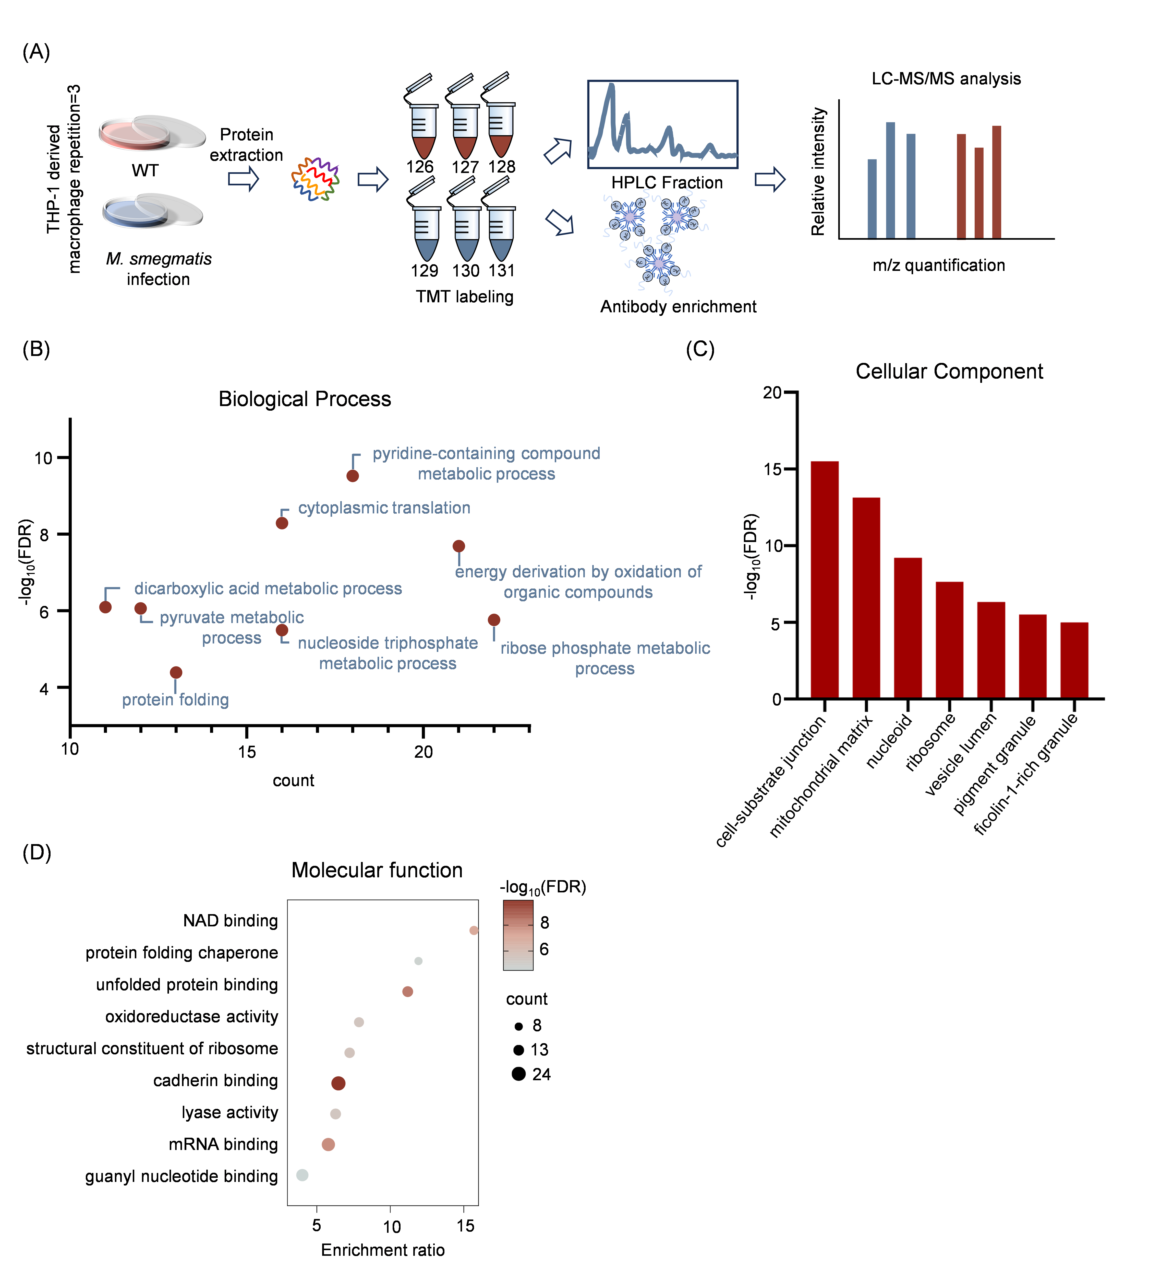

Figure S1. M. smegmatis infection affects host acetylation level. (A) The experimental design of the TMT-based quantitative acetylome analysis after M. smegmatis infection. (B) Biological process enrichment of acetylation up-regulated proteins. (C) Cellular component enrichment of acetylation up-regulated proteins. (D) Molecular function enrichment of acetylation up-regulated proteins. All pathway enrichment FDR < 0.05.

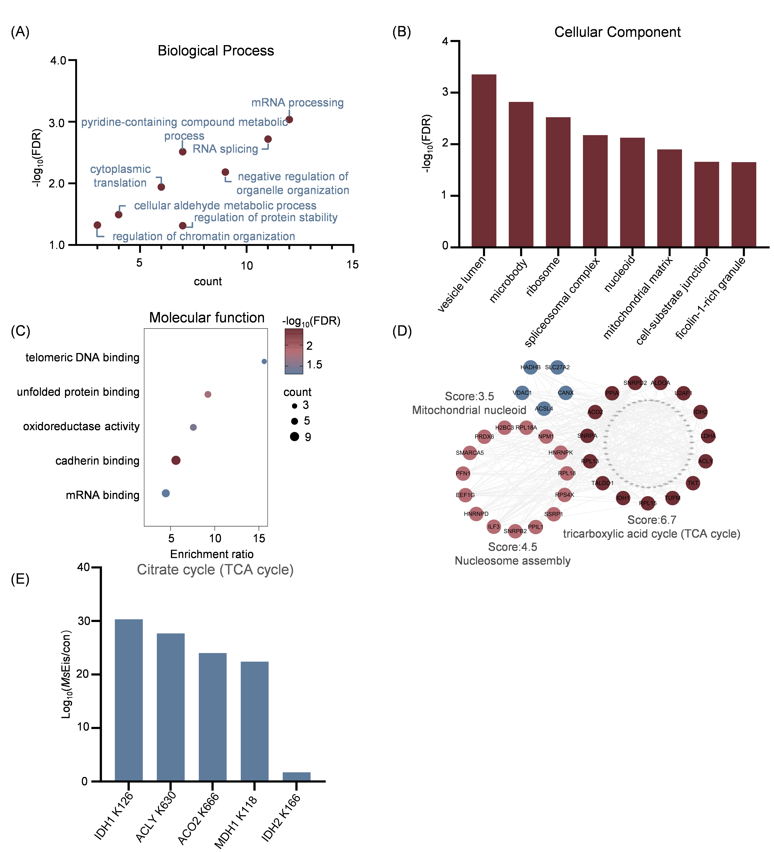

Figure S2. Eis causes global characterization of the dynamic acetylation in host. (A) Biological process enrichment of acetylation proteins. (B) Cellular component enrichment acetylation proteins. (C) Molecular function enrichment of acetylation proteins. All pathway enrichment FDR < 0.05. (D) Protein-protein interaction network analysis of acetylated proteins. (E) Change ratio of acetylation sites enriched in the tricarboxylic acid cycle (TCA cycle).

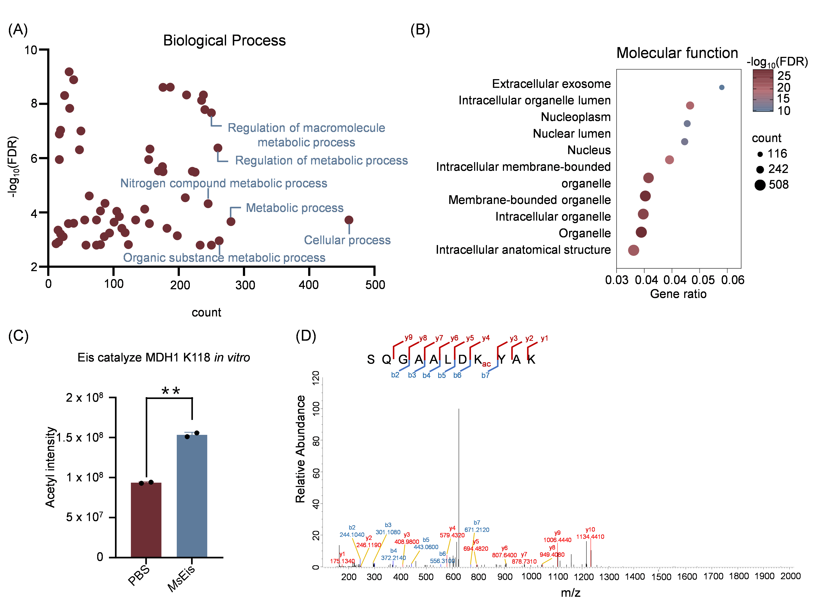

Figure S3. MsEis regulatory and interaction omics analysis. (A) Biological process enrichment of MsEis interacting proteins. (B) Molecular Function enrichment of MsEis interacting proteins. All pathway enrichment FDR < 0.05. (C) MsEis catalyze MDH1 K118 in vitro. (D) MS/MS spectra of the acetylated peptides showing modified K118 site of MDH1 after MsEis catalysis.

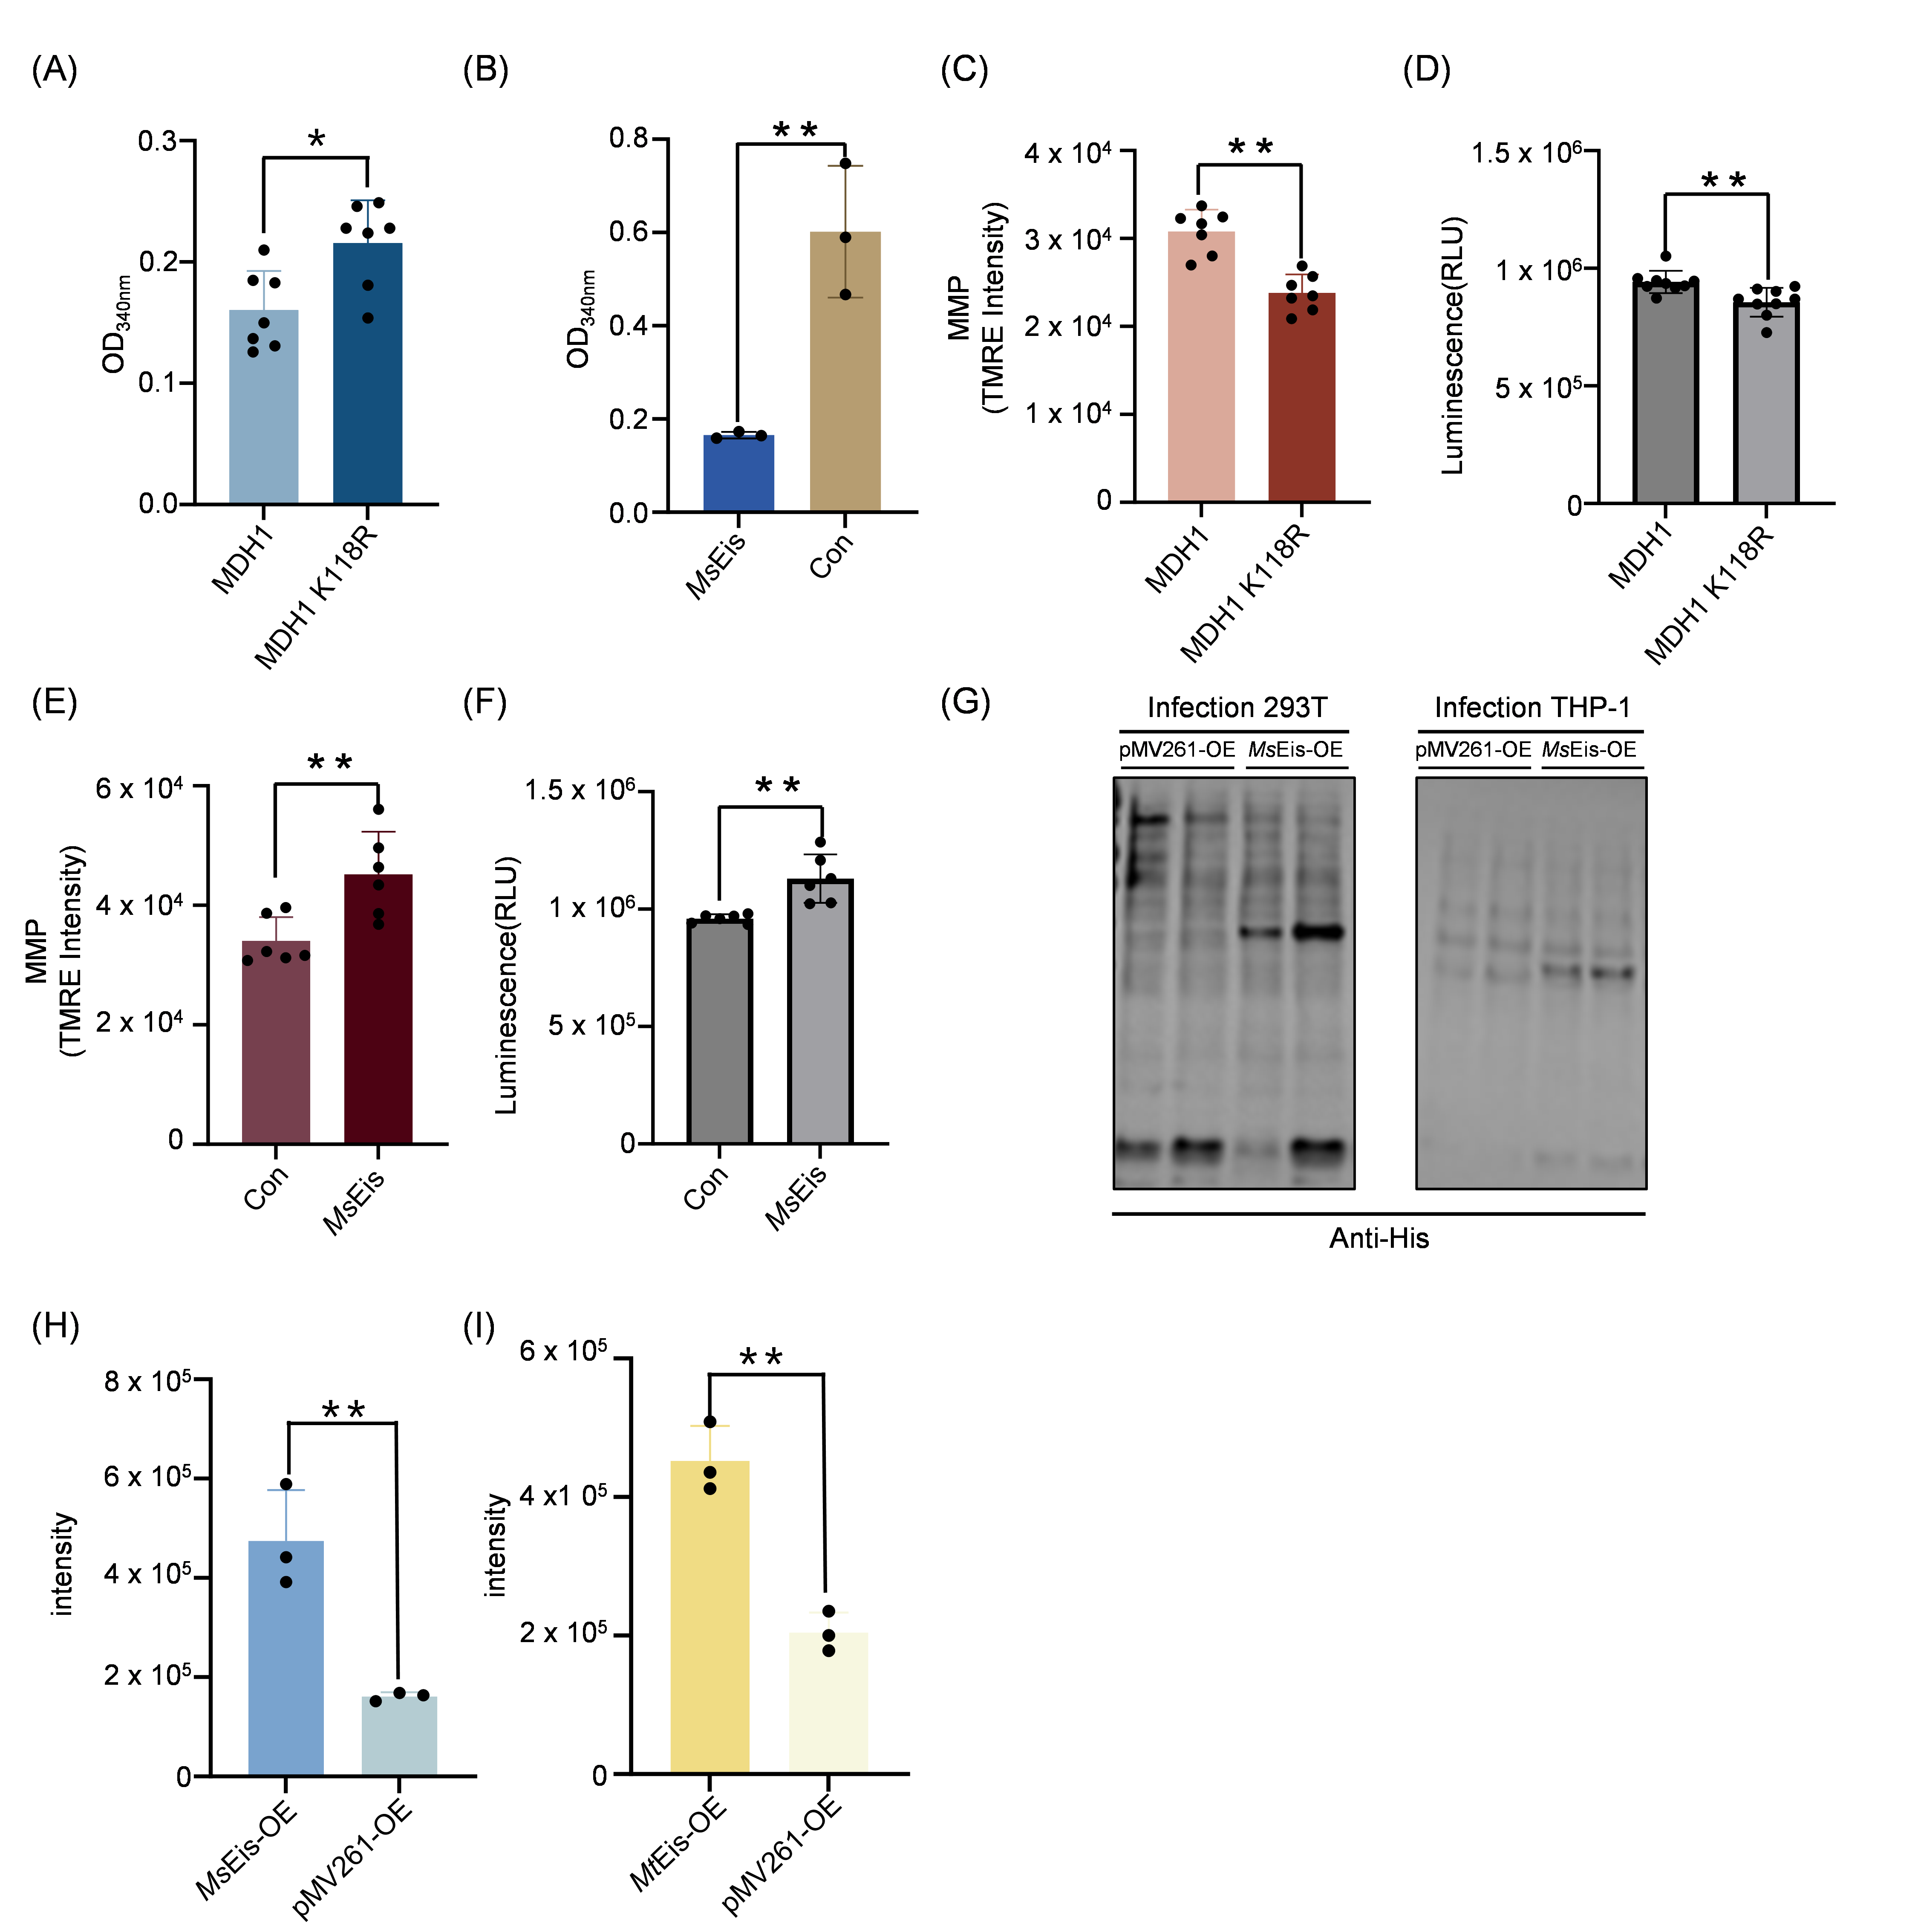
Figure S4. MsEis regulation of mitochondrial function. (A) The activity of MDH1 and MDH1 K118R measured by absorbance at OD340nm (n = 7 per group, *p < 0.05, Student’s t-test, bars indicate mean ± SEM) (B) Enzyme activity is measured by absorbance at 340 nm after MsEis catalyzes MDH1 (n = 3 per group, **p < 0.01, Student’s t-test, bars indicate mean ± SEM). (C) MDH1 and MDH1 k118R overexpression and staining of mitochondria with TMRE to reflect the mitochondrial membrane potential (MMP) (n = 7 per group, **p < 0.01, Student’s t-test, bars indicate mean ± SEM). (D) The change of ATP levels after MDH1 and MDH1 K118R overexpression (n = 9 per group, **p < 0.01, Student’s t-test, bars indicate mean ± SEM). (E) MsEis overexpression and staining of mitochondria with TMRE to reflect the mitochondrial membrane potential (MMP) (n = 6 per group, **p < 0.01, Student’s t-test, bars indicate mean ± SEM). (F) The change of ATP levels after MsEis overexpression (n = 6 per group, **p < 0.01, Student’s t-test, bars indicate mean ± SEM). (G) THP‑1‑derived macrophages and HEK-293T cells were infected with the MsEis‑His‑OE strain, followed by Western blot analysis. (H) MsEis-OE strain was verified by mass spectrometry. (I) MtEis-OE strain was verified by mass spectrometry.

Figure S5. Impact of MsEis-OE strain or MtEis-OE strain infection host on mitochondria. (A) Proteins that are commonly upregulated in hosts infected by MsEis-OE strain and MtEis-OE. (B) Proteins that are commonly downregulated in hosts infected by MsEis-OE strain and MtEis-OE. (C) Overlap of MsEis‑OE‑upregulated and MtEis‑OE‑downregulated proteins. (D) Overlap of MsEis‑OE‑downregulated and MtEis‑OE‑upregulated proteins. (E) KEGG enrichment of proteome after MsEis-OE strain infection. (F) Cellular component enrichment of proteome after MsEis-OE strain infection. Proteins were down (blue) or up (red) regulated. (G) KEGG enrichment of proteome after MtEis-OE strain infection. Proteins were down (blue) or up (red) regulated. (H) Cellular component enrichment of proteome after MtEis-OE strain infection. Proteins were down (blue) or up (red) regulated.

Figure S6. MsEis-OE strain infection omics analysis. (A) Biological process enrichment of down-regulated proteins after MsEis-OE strain infection. (B) Molecular function enrichment of down-regulated proteins after MsEis-OE strain infection. All pathway enrichment FDR < 0.05.

Figure S7. Impact of MsEis-OE strain infection host on mitochondria. (A) The change of mitochondrial membrane proteins after MsEis-OE strain infection (*p < 0.05, **p < 0.01, Student’s t-test), proteins were down (blue) or up (red) regulated. (B) The change of glutathione metabolism proteins after MsEis-OE strain infection (*P < 0.05, Student’s t-test). (C) The change of ubiquitin-like protein conjugating proteins after MsEis-OE strain infection (*p < 0.05, Student’s t-test). (D) The change of nucleotide metabolic proteins after MsEis-OE strain infection (*p < 0.05, **p < 0.01, Student’s t-test), proteins were down (blue) or up (red) regulated.

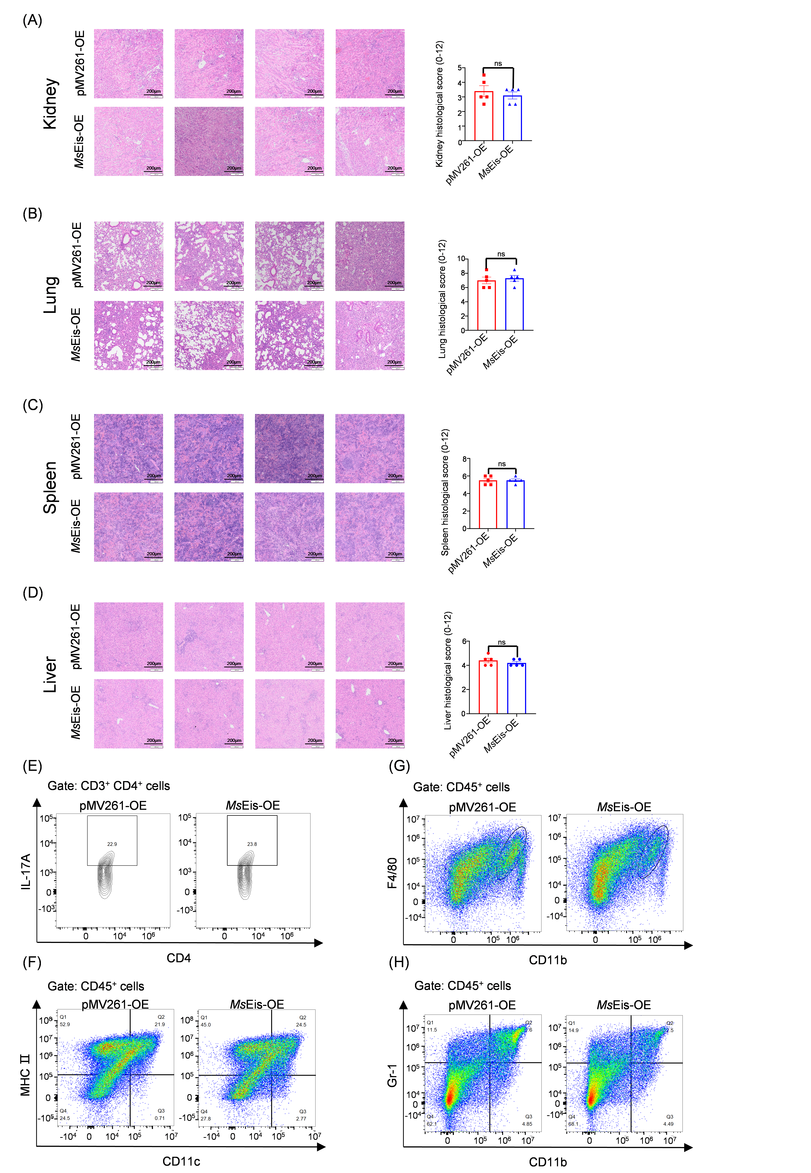

Figure S8. Multi-organ histopathology and splenic immune profiling by flow cytometry in infected mice. (A-D) Representative H&E-stained sections and semi-quantitative histology scores of the kidney (A), lung (B), spleen (C), and liver (D) from each group (n = 5 per group). Scale bar represent 200 µm. Representative H&E images shown in the main and supplementary figures were obtained from different mice within the same cohort (total n = 5 mice per group). For each organ, the total score (0-12) was calculated as the sum of inflammation (0-4), hemorrhage (0-4), and structural damage (0-4). All five mice per group were included in the histopathology scoring. (n = 5 mice per group, ns, not significant, Student’s t-test) (E) Representative contour plots gated on splenic CD3⁺ CD4⁺ cells showing CD4 (x-axis) vs IL-17A (y-axis), with numbers within quadrants denoting the percentage of each gated subset. (F-H) Representative flow cytometry pseudocolor plots, dendritic cells (DCs, CD45⁺ MHCII⁺ CD11c⁺, F), macrophages (CD45⁺ F4/80⁺ CD11b⁺, G), and myeloid-derived suppressor cells like (MDSCs-like, CD45⁺ Gr-1⁺ CD11b⁺, H). Plots are gated on CD45⁺ cells, with numbers in the gates representing the percentage of the parent population.

